Assignment - 1

|  |  |
| --- | --- |
| **Student Name/ID Number:** | I Kadek Wahyu Dwi Prastika |
| **Academic Year:** | 2022 |
| **Module Name:** | Front End Web Development |
| **Project Title:** | Information Architecture, Wireframe and Story Board |
| **Submission Date:** | 7 April 2022 |



7 April 2022

Date:

Student signature:

I certify that the work submitted for this assignment is my own and research sources are fully acknowledged.

**Learner declaration**

|  |
| --- |
| **Purpose of this project** |
| **Purpose of this project**  To demonstrate your capabilities in the following areas:   * Plan a Website & Develop branding, wireframes, information architecture & storyboard. |
| **Submission Format** |
| In one document, submit the following:   1. Information Architecture, 2. Wireframe, and 3. Storyboard |
| **Project Brief & Guidance** |
| **Scenario:**  You have been approached by ‘ABC Learning Center’ as a website developer to develop a  company portfolio website for their institute. ‘ABC Learning Center’ is an IT Training institute that conducts courses like ‘Programming in Java’, ‘Programming in .Net’,  ‘Microsoft Office’, ‘HTML’ etc. They want to design a website which can be used for  providing information about their courses to students.  You will be required to design and develop this website using HTML, JavaScript, and CSS. For Assignment 1, you will be required to design following pages for the website –   1. Common Content    1. Header    2. Footer    3. Navigation 2. Home Page 3. About Us Page / Profile Page 4. Contact Us Page (Develop 1 Html page) 5. Course Details Page (Develop 2 pages, 1 for each course) 6. Course Schedule Page (Develop 2 pages, 1 for each course) 7. Sitemap Page (Develop 1 HTML page) 8. Privacy Policy Page (Develop 1 HTML page) |

**Information Architecture**

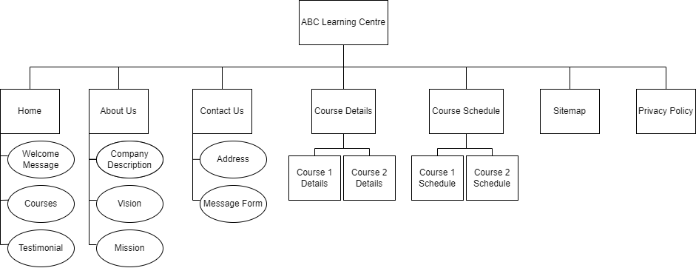

In this information architecture, I have some pages that are: Home page that shows some general information about the website/company, About Us shows about what is our company and more specific information related to our company, Contact Us shows a form that can send user message to the admin and an address of the office, Course Details that are divided into 2 sections: Course 1 detail and Course 2 detail, Course Schedule is also divided into 2 pages that are Course 1 Schedule and Course 2 Schedule, Sitemap that shows the structure of the website, and Privacy Policy.

**Wireframe**

**Home Page**

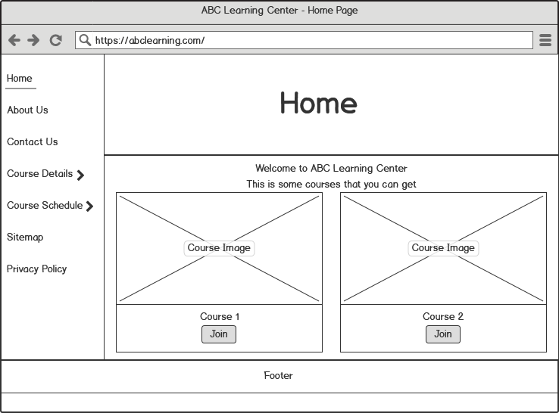

So this is a wireframe for the home page. On this page, we will insert most of the general information about our company, and in this case, I will insert the courses.

**About Us**

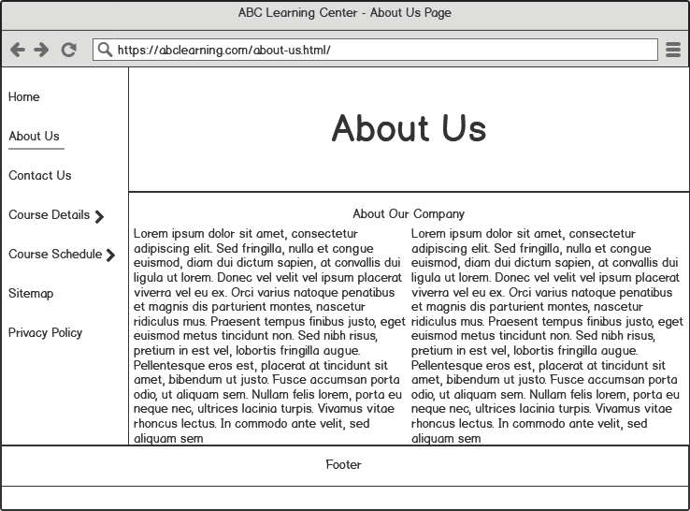

In About Us Wireframe, I added some random text that if this makes into a real webpage, the text is going to be specific information about our company. We can show how the company made, what is the vision and the mission, and something else that related to the company.

**Contact Us**

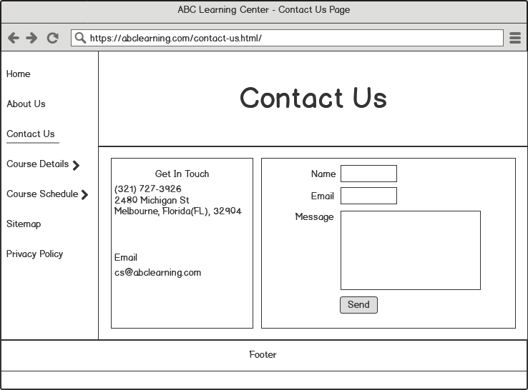

On this page (Contact Us), we can show the company address and a form that users can use to send a message to the admin.

**Course Details -> Course 1**

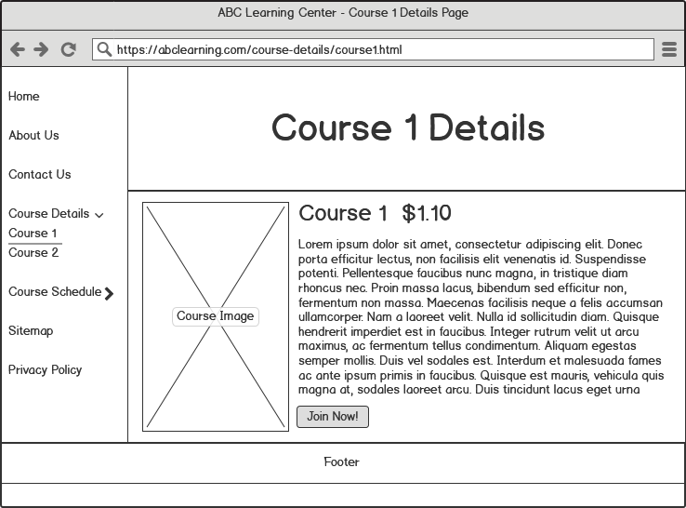

On this page, we show a course detail, in this case, this page is showing the detail of course 1. We also put an image of the course, the price of the course, and then a button to join the course.

**Course Details -> Course 2**

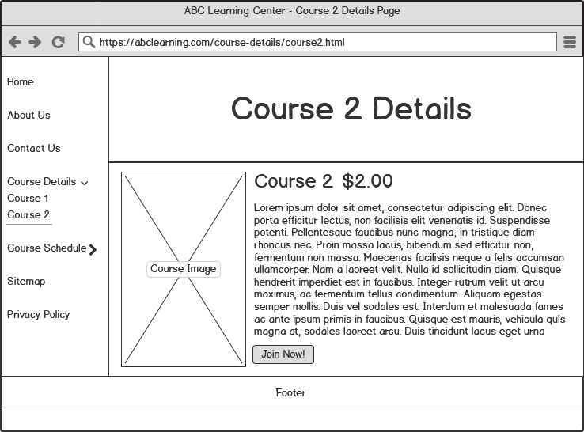

This is the same as the Course 1 detail, but this is showing the detail of course 2.

**Course Schedule -> Course 1**

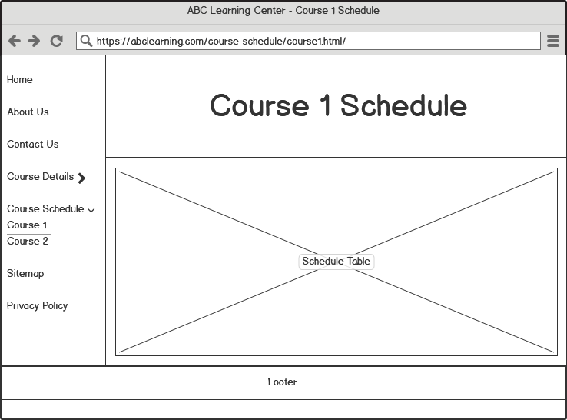

So Basically, this page is showing the schedule of the course, so we just insert a table of the schedule on this page.

**Course Schedule -> Course 2**

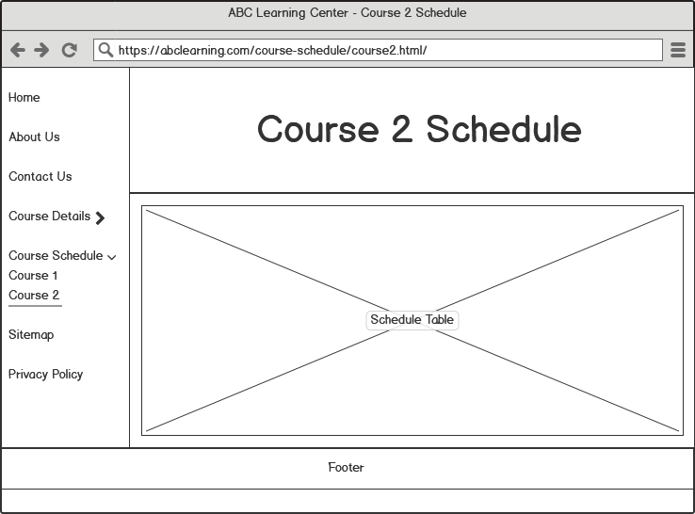

This is exactly the same as the Course 1 Schedule, but this is showing the Course 2 Schedule.

**Sitemap**

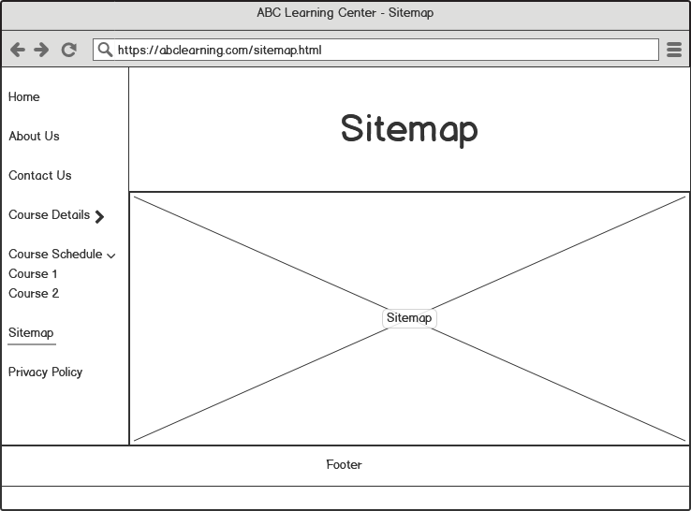

So on this page, we are going to show a sitemap that is the structure of the website on this one page. You can also see the wireframe of this website at the beginning of this document.

**Privacy Policy**

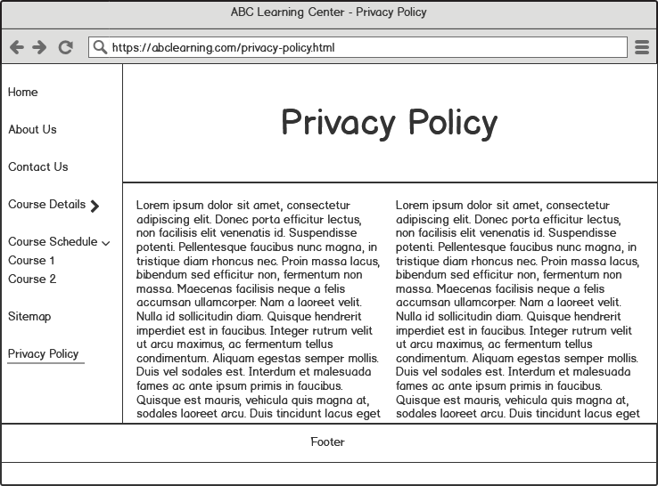

On this page, we show the privacy policy of the webpage. This page is important because you can prevent all of the bad things happened on this webpage.

**Storyboard**

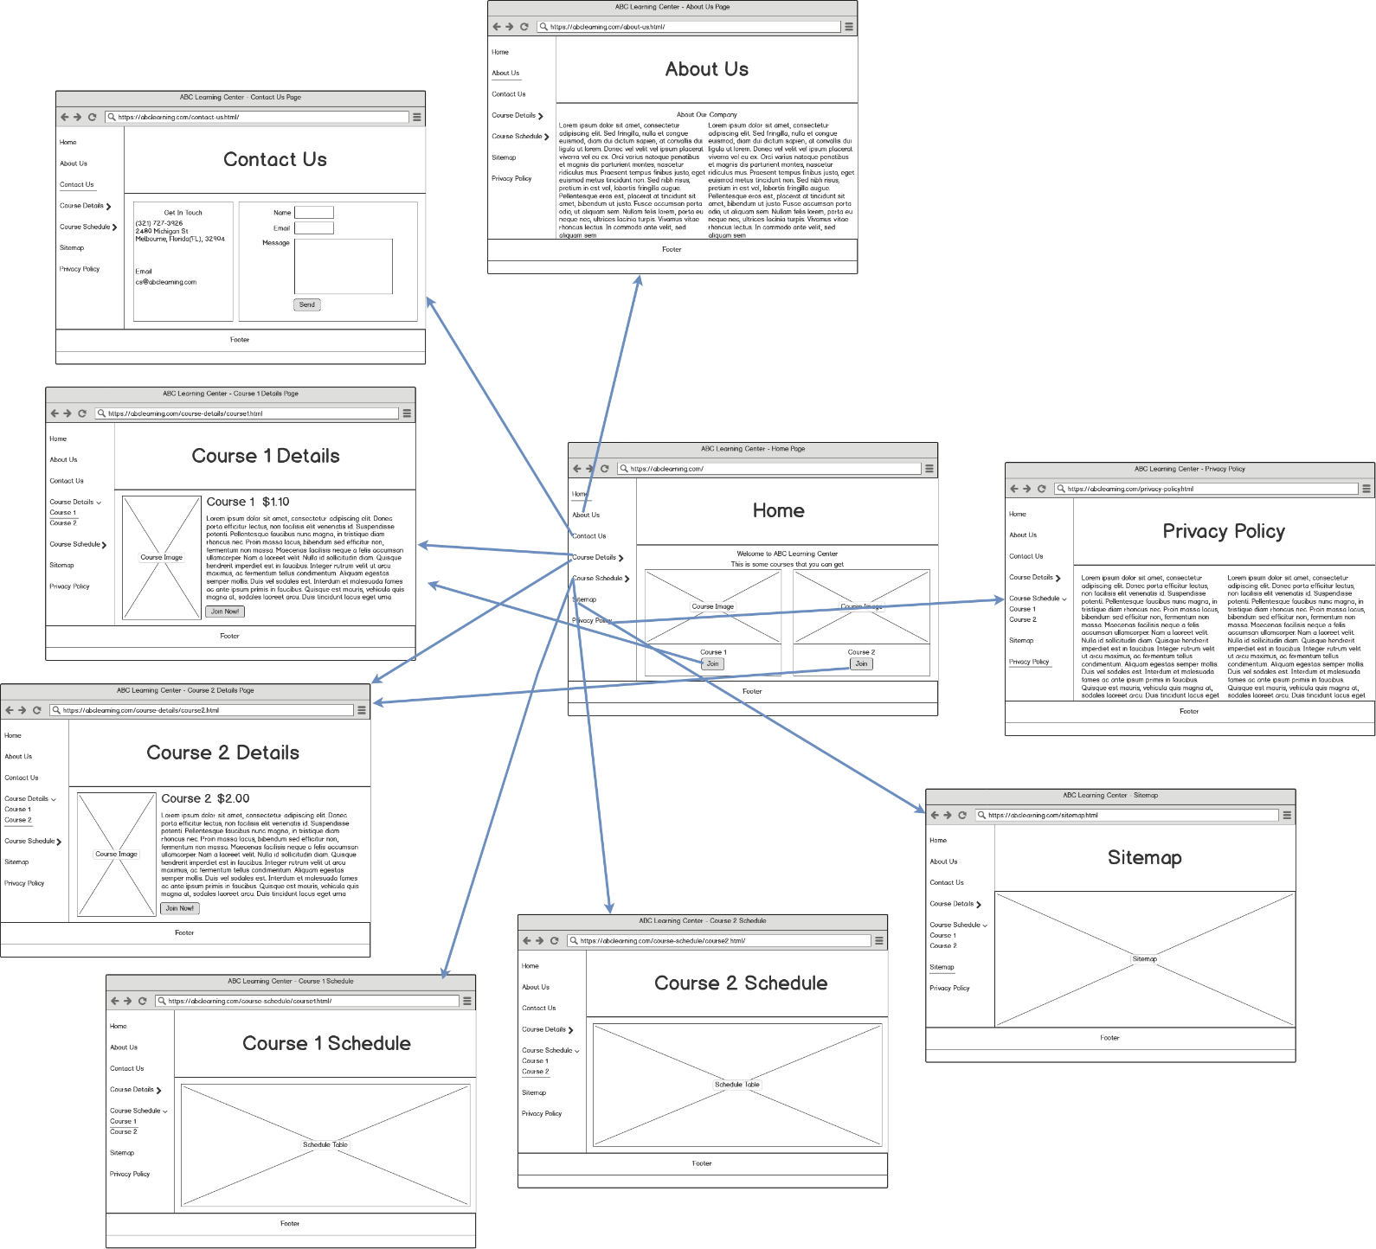

This is a storyboard of the website. In this storyboard, we can see the flow of the website. You also can see that all of the webpages are related to each other.